CODEALPHA CYBER SECURITY INTERNSHIP

TASK 1: BASIC NETWORK SNIFFER

Submitted By:
Chintham Jashnavi

Domain:
Cyber Security

Organization:
CodeAlpha

Submission Date:
23 May 2026

OBJECTIVE:
The objective of this project is to build a basic network sniffer using Python and Scapy to capture and analyze network packets.

TOOLS USED:
• Python
• Scapy
• VS Code
• Npcap
• Windows OS

PROJECT DESCRIPTION:
This project is a basic network sniffer developed using Python and Scapy. It captures network traffic and displays source IP address, destination IP address, protocol type, and payload information.

PROCEDURE:
1. Installed Python and VS Code.
2. Installed Scapy library.
3. Installed Npcap for packet capturing.
4. Created sniffer.py file.
5. Executed the Python program.
6. Captured live network packets.
7. Analyzed source and destination IP addresses.

SOURCE CODE:
->sniffer.py:
from scapy.all import sniff
from scapy.layers.inet import IP, TCP, UDP

# Function to process packets
def packet_callback(packet):

print("\n=== Packet Captured ===")

if packet.haslayer(IP):

source_ip = packet[IP].src
destination_ip = packet[IP].dst

print(f"Source IP: {source_ip}")
print(f"Destination IP: {destination_ip}")

if packet.haslayer(TCP):
print("Protocol Type: TCP")

elif packet.haslayer(UDP):
print("Protocol Type: UDP")

else:
print("Other Protocol")

payload = bytes(packet.payload)

if payload:
print(f"Payload: {payload[:50]}")

print("Starting Network Sniffer...")

sniff(prn=packet_callback, store=False)

OUTPUT SCREENSHOTS:
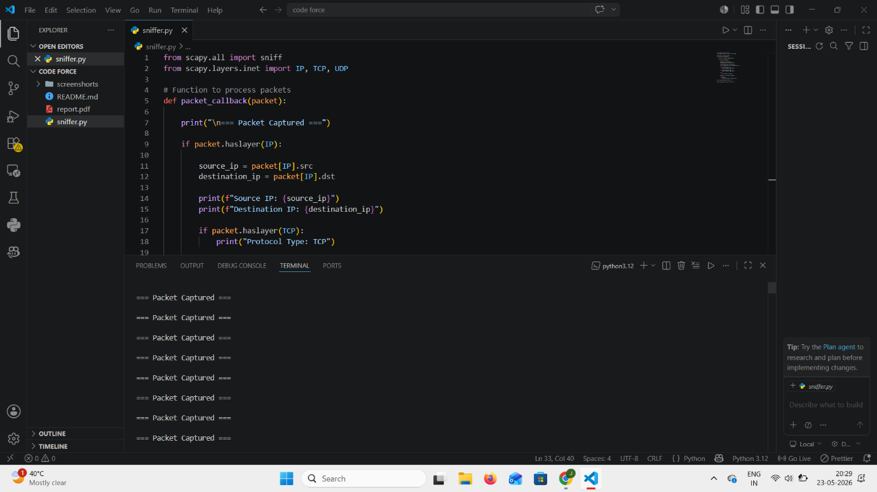
Figure 1: Execution of the Basic Network Sniffer program in VS Code showing live packet capturing using Scapy.
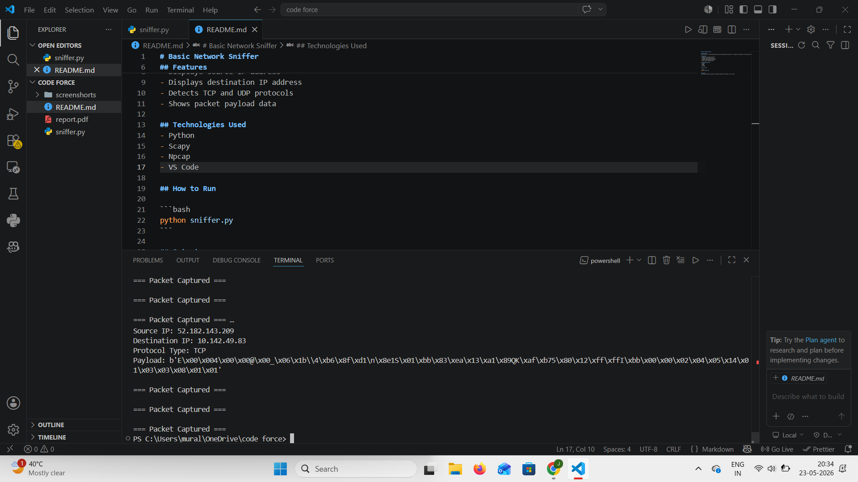
Figure 2: Live network packet capture displaying source IP address, destination IP address, protocol type, and payload information.

RESULT:
The network sniffer successfully captured live packets and displayed network packet details including IP addresses and protocols.
CONCLUSION:
This project helped in understanding packet capturing, network communication, and network traffic analysis using Python and Scapy.

